

**“Synopsis”**

**On**

**“JU QUERY**”

Submitted in partial fulfilment for the award of the Degree of

**BACHELOR OF TECHNOLOGY IN COMPUTER SCIENCE ENGINEERING**

**(SOFTWARE ENGINEERING)**

**Submitted by**

**R. SRISARVESH 18BTRSE027**

**T. Aswin Barath 18BTRSE031**

**Souvik Kar 18BTRSE026**

**Vyshnav Raj 18BTRSE033**

**Under the guidance of**

**Ms Sujatha. K**

**Professor**

**Faculty of Engineering & Technology Jain (Deemed-To-Be University)**

**Department Computer Science & Engineering**

**Jain Global Campus, Kanakapura Taluk - 56211 Ramanagara District, Karnataka, India 2021-2022**

**Introduction**

In our mini-project, we are going to build an application called “Ju query” which is a platform for the purpose of knowing about the academic and nonacademic environment, campus life of a student, faculty and student relationship of Jain University in a virtual way.

This application provides us with complete information about campus life from a student point of view, and academic information from a college point of view.

It features a familiar and well-thought-out and attractive user interface, much like posting a query, giving a response to a query.

The main aim to develop this app is to connect students around the campus virtually and share things with each other to clarify their doubts.

**How are people benefited from using this app?**

Students with doubts about a particular topic or want to know about something that is going inside the campus and want to get to know about it can use this app to post a query and students who want to answer the question and help other fellow students can answer the question in the post.

**Literature Survey**

Community-based Question Answering destinations enable users to find solutions to complex, point by point and individual questions from different users. Be that as it may, since answering a question relies upon the capacity and readiness of users to address the asker's needs, a huge portion of the questions stay unanswered.

Community-based Question and Answering (CQA) administrations have conveyed users to another period of information dispersal by enabling users to make inquiries and to answer other users' questions.

A fresher just took admission to Jain University, does not know anything about college and does not have any connection to others. He/ She can directly take our application and can find out his/ her queries. If his / her query is not present then can post his/ her query here.

The system will ensure the students do not provide any fake answers or events through our site. The student will be able to see the live events happening on campus.

**Methodology**

Platform: JavaScript Web Application

Libraries and Frameworks used:

-> React

-> Redux

-> Firebase API

**1 Architecture Design**

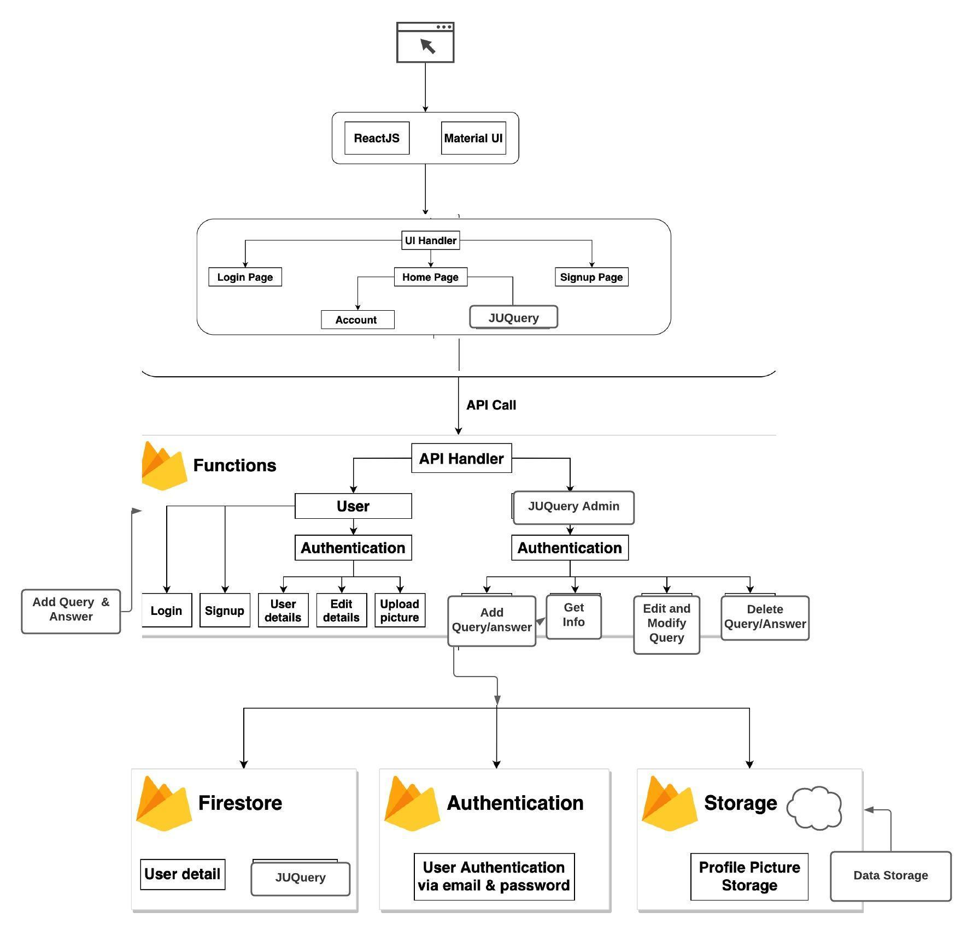

**2 Use case Diagram**

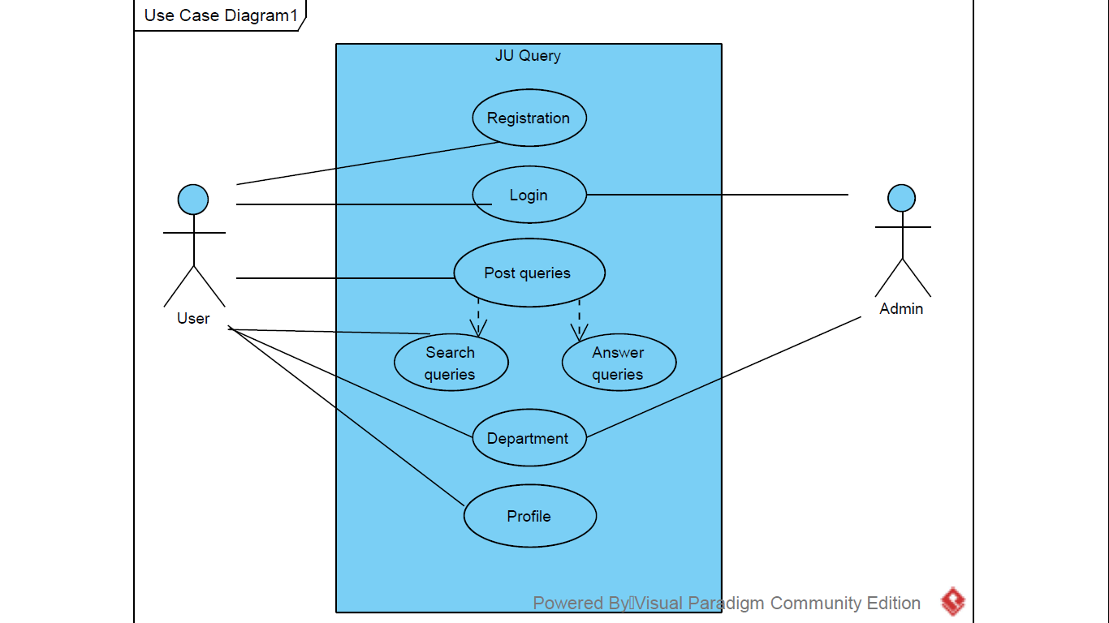

**3 ER Diagram**

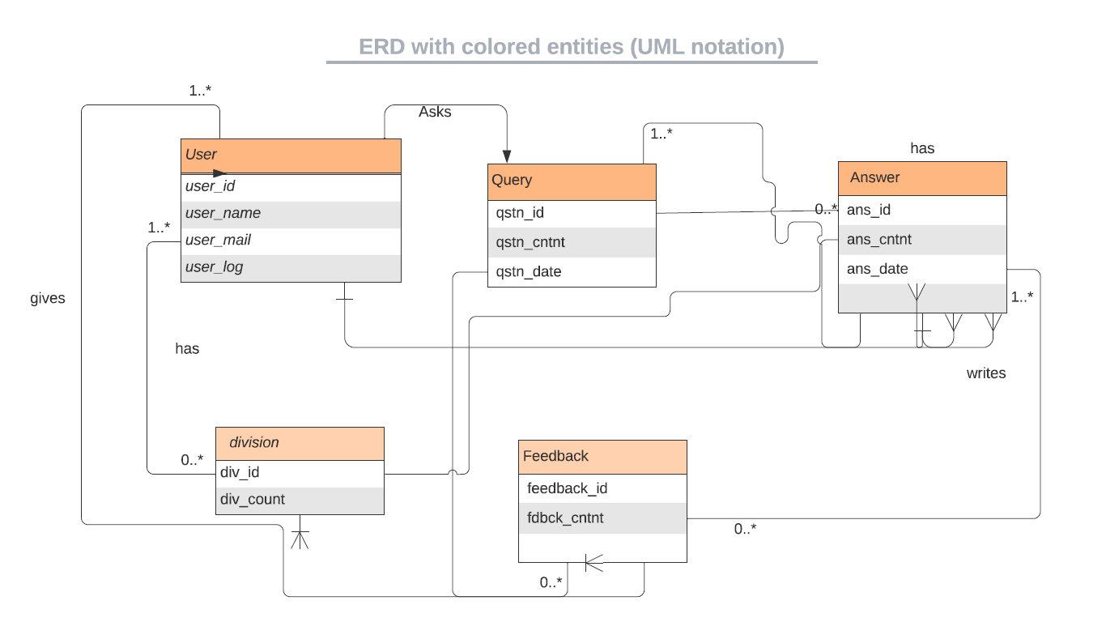

**4 Activity Diagram**

**4.1 Activity Diagram for Admin Side**

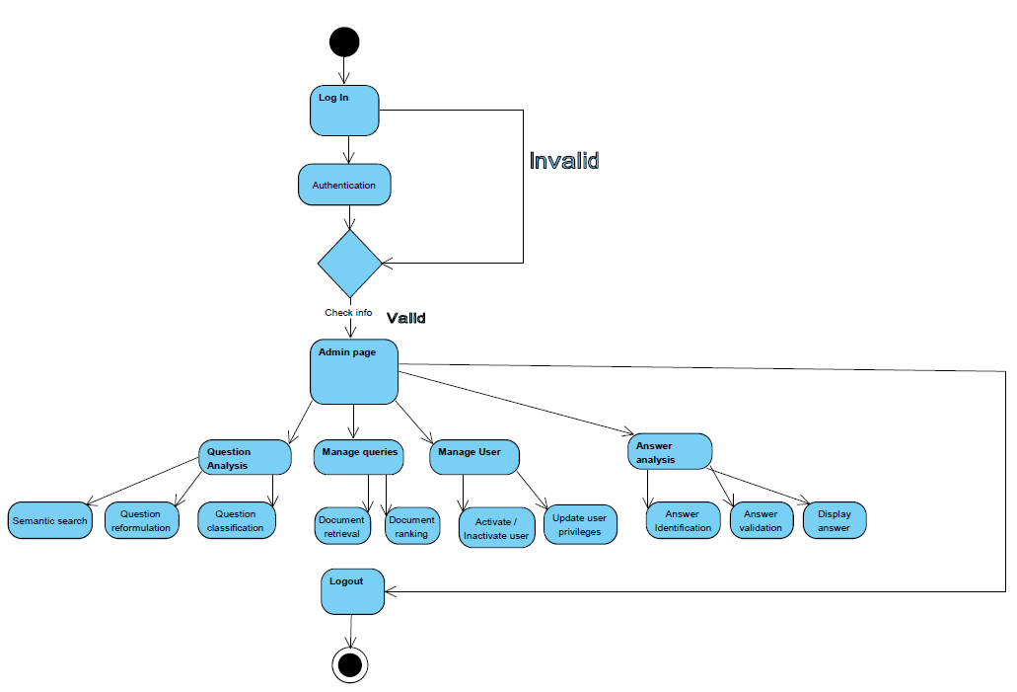

**4.2 Activity Diagram for User Side**

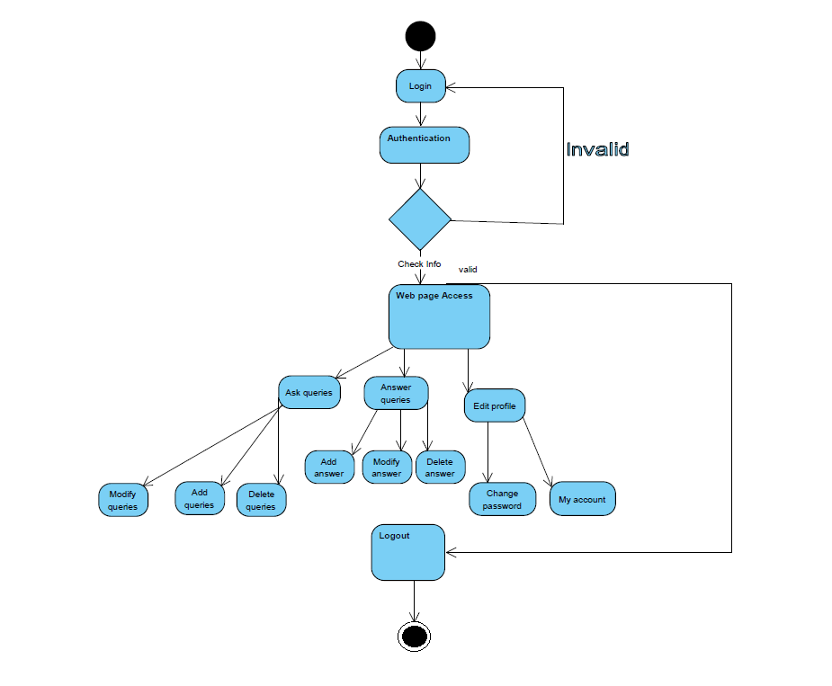

**5 Class Diagram**

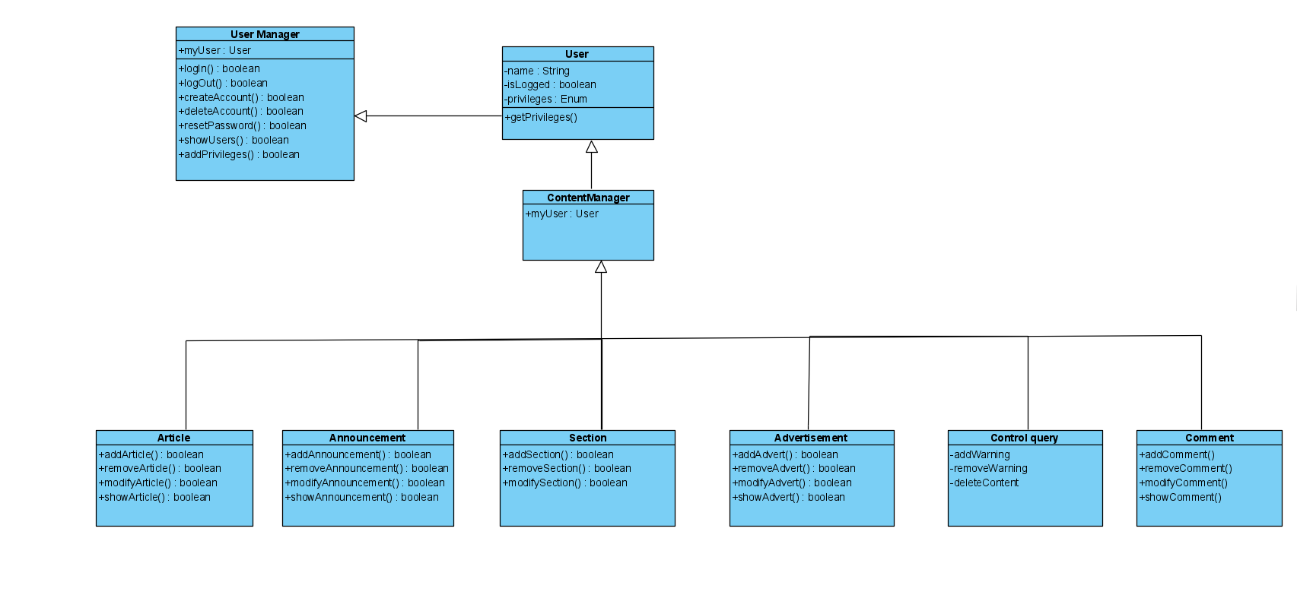

**Hardware and Software Requirements:**

*Hardware Requirements*

* An Intel Pentium 4 processor or later that's SSE3 capable
* 1 GB of RAM
* 1.6 GHz or faster processor
* Hard disk space: 10 GB or above
* Keyboard and mouse or other pointing device
* Network adapters for connection to the Internet
* Graphics display resolution

### *Software Requirements*

### *Operating System Requirements:*

* OS X El Capitán (10.11+)
* Windows 7 (with .NET Framework 4.5.2), 8.0, 8.1 and 10 (32-bit and 64-bit)
* Linux (Debian): Ubuntu Desktop 16.04, Debian 9
* Linux (Red Hat): Red Hat Enterprise Linux 7, CentOS 8, Fedora 24

*Client-side Software Requirements:*

* Google Chrome
* Visual Studio Code
* Git Bash
* Command Prompt
* Windows Powershell

*Developer libraries:*

* React.js
* React-modal
* Redux.js
* Material-ui
* Firebase
* React-testing-library

**Future Scopes**

In this project, we have done an application that helps the students of a college to get to know about their academic and non-academic information from the students perspective.

And every student of the college can post any query they want to post and anyone who wants to answer the post can do that. This process enables students across the campus even from different departments to interact with each other and get collaborative knowledge.

And we have 9 different kinds of categories where we can have questions about and if the question the student wants to ask is not listed in the type of the category he can select others and can still post.

And in the future, there will be features like a chat option where students in the college can connect to a fellow student and can have a conversation with the student. And also students can organize an event through this application and students can register for the event they wanted to through this application.

**References**

1. Quora - <https://www.quora.com/>
2. Stack Overflow - <https://stackoverflow.com/>